UCCC2513 Assignment
A R&D proposal to detect traffic signs

The task here is to create a R&D (Research & Development) proposal to detect traffic signs reliably for autonomous vehicles. Students should work in groups of 3 or 4 members. Eighty-four test images are provided in the directory “Traffic signs” (which can be found in the directory of “Color Inputs” at MS Teams) for testing purpose. Figure 1 below shows one example of the test image and the desirable intermediate result to segment a sign. Figure 2 shows more examples of the signs with the colors red, blue and yellow. The shapes of the signs can be circle, triangle, rectangle and octagon.

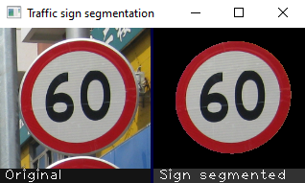
Figure 1: One example of a test image and its segmentation result

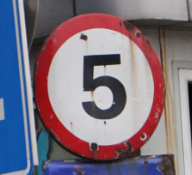 | 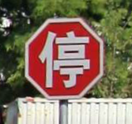 | 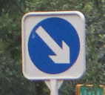
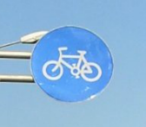 | 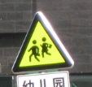 | 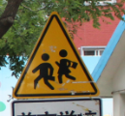
Figure 2: Examples of 6 test images with different colors and shape

1. DETAILS

Your team or company needs funding to support this development and your career. You know of one mini-project fund of RM1,000,000 to support such development. Unfortunately, there are other teams / companies competing to get this project and fund. Hence, your team needs to produce an exceptionally good R&D proposal to beat others.

After brainstorming, your team concludes that the combination of the information like color and shape can help to segment traffic signs reliably. Afterward, the task of detection/recognition would be easy. Hence, members should check on past work on effective color/shape detection and traffic sign recognition in general. To beat other teams, members should research the most promising and recent techniques. Afterward, the members can get together to share their findings to come up with a superior system design.

Finally, each team needs to submit a proposal (equivalent to the FYP1 report) to the funding reviewing committee to get the award of RM 1,000,000. To beat others, the proposal should highlight members’ knowledge and expertise on the most updated techniques, e.g. color and shape detections (in chapter 2 of the proposal as shown in the next section below) and the superior system design with novel / new idea (in chapter 3). To play safe, some members should also look beyond color and shape into alternative approaches for sign segmentation / detection. The findings should be put in the proposal (chapter 2) too. The most updated and effective techniques should be within the last 10 (or 5) years since older approaches are likely obsolete.

Afterward, to show proof the proposed exciting design can work, some pieces of preliminary work should be carried out to clear doubt on the novel idea. This should be reported in chapter 4 of the proposal. Your proposal can then stand out tall to support application of the funding.

For this report, you need to present a complete design of the whole system. For chapter 4, the preliminary work should give result up to the part of sign segmentation as in chapter 1.

2. REPORT

The proposal report writing becomes easy by following the template file “FYP1_Report_Template_CS (New)” from FICT FYP portal. The proposal will be marked according to the FYP1 rubrics. Five main chapters should be produced. They are summarized below.

Chapter | Contents | Marks
1 | Introduction | 3
2 | Literature Review | 12
3 | Proposed Method / Approach | 8
4 | Preliminary Work | 5
5 | Conclusion | 2
6 | Presentation & demo | 10

The content detail of each chapter will be discussed in class. Other small but important details that you should know are:

- W⁵H: This represents the terms What, Why, When, Who, Where and How with respect to the assignment title. Usually, we pay more attention to what, why and how when writing each chapter. In this report, you need to provide and explain what the system design is (i.e. the system block diagram or flowchart), why this design and how each of the details works together to form the final system.
- One picture is worth 1000 words. Hence, it will be to your advantage to provide and explain using system block diagrams or flowcharts.
- Excluding the code, diagrams and images from the intermediate results, the written report should not exceed 30 pages with double spacing and font sizes 10 to 12 using the font “Times New Roman”.
- Report will be graded on clarity and authenticity.
- Each report section and source code section should be tagged with name of the group member who produces the writing and / or the implementation.
- University regulation prohibits plagiarism. If caught, you will end up with an “F” grade.
- Late project will not be accepted after the due date under any circumstances.
- Each team member is required to choose and develop one specific module as listed below for chapter 4 (Preliminary Work):

Member 1 | Red sign segmentation using color information
Member 2 | Blue sign segmentation using color information
Member 3 | Yellow sign segmentation using color information
Member 4 | Shape detection of signs to support the segmentation

3. PRESENTATION & DEMONSTRATION

Besides the report, you are required to provide a short video of presentation of the proposal and demonstration running your code and displaying the preliminary work results. The demo should read the names of input image files from a specific directory.

4. HINTS

One can find numerous pieces of demo and code using OpenCV from the Internet to segment traffic sign. You can refer / reuse them for your code. Cite the sources in your report if you reuse or adapt their code.

